**PROJECT DESIGN PHASE-II**

**DATA FLOW DIAGRAM & USER STORIES**

|  |  |
| --- | --- |
| **DATE** | 21 October 2022 |
| **TEAM ID** | PNT2022TMID24852 |
| **PROJECT** | IOT BASED CROP PROTECTION SYSTEM |
| **MAXIMUM MARKS** | 4 MARKS |

**DATA FLOW DIAGRAM:**

A Data Flow Diagram (DFD) is a traditional visual representation of the information flows within a system. A neat and clear DFD can depict the right amount of the system requirement graphically. It shows how data enters and leaves the system, what changes the information, and where data is stored.

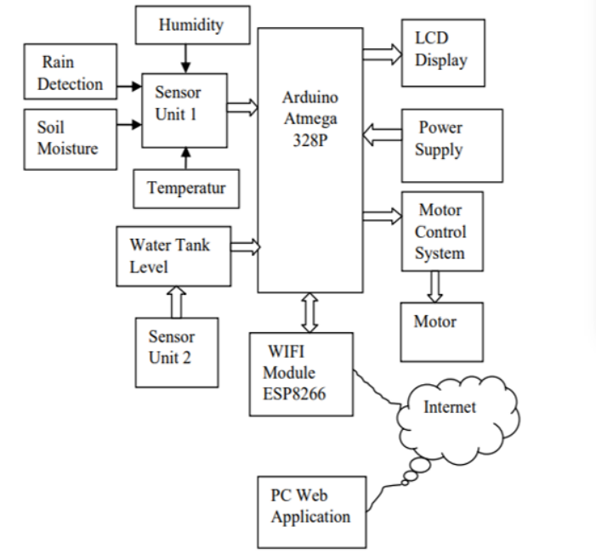

**USER STORIES:**

Use the below template to list all the user stories for the product.

|  |  |  |  |  |  |  |
| --- | --- | --- | --- | --- | --- | --- |
| **User Type** | **Functional requirement (Epic)** | **User Story Number** | **User Story/Task** | **Acceptance criteria** | **Priority** | **Release** |
| Customer (Mobile user) | Registration | USN-1 | As a User, we can enter into the web application | I can access my account /dashboard | High | Sprint 1 |
|  |  | USN-2 | User can register their credentials like email id and password | I can receive confirmation email & click confirm | High | Sprint 1 |
|  | Login | USN-3 | User can log into the application by entering email & password | I can login to my account | High | Sprint 1 |
|  | Dashboard | USN-4 | User can view the temperature | I can view the data given by the device | High | Sprint 2 |
|  |  | USN-5 | User can view the level of sensor monitoring value | I can view the data given by the device | High | Sprint 2 |
| Customer (Web user) | Usage | USN-1 | User can view the web page and get the information | I can view the data given by the device | High | Sprint 3 |
| Customer | Working | USN-1 | User act according to the alert given by the device | I can get the data work according to it | High | Sprint 3 |
|  |  | USN-2 | User turns ON Buzzer/Sound Alarm when the disturbance will occur on field | I can solve the issues when someone fails to understand the procedures | High | Sprint 4 |
| Customer care Executive | Action | USN-1 | User solve the problem when some faces any usage issues | I can solve the issues when someone fails to understand the procedures | High | Sprint 4 |
| Administration | Administration. | USN-1 | User store every information | I can store the gained | High | Sprint 4 |